**Game Rules**

The game is for 4-6 players.

Set-up:

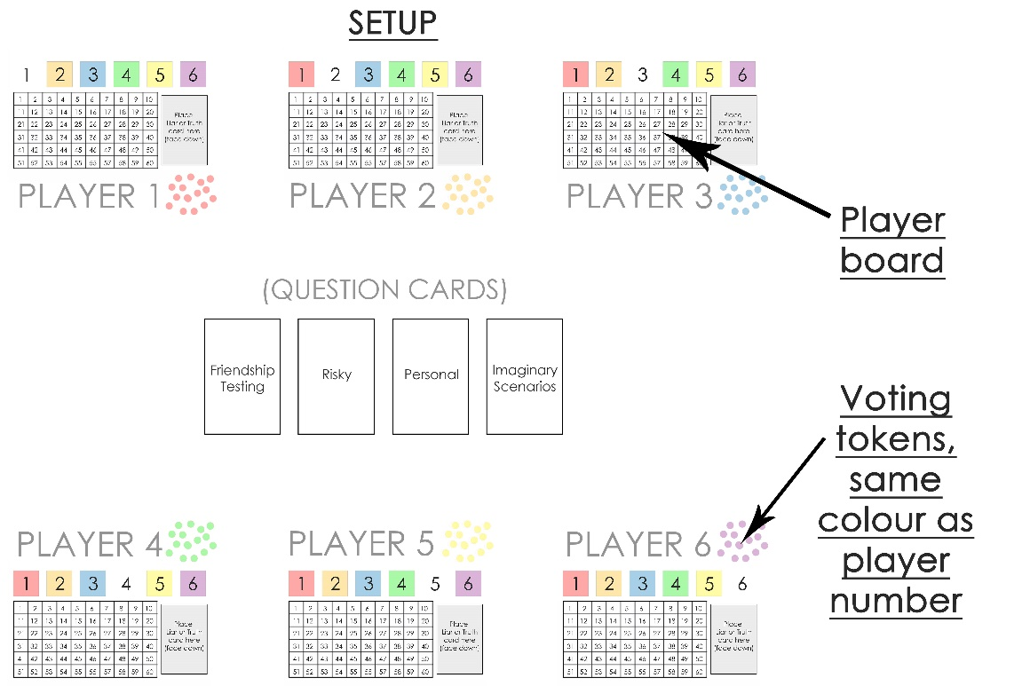

Depending on the amount of people playing, you will always need 2 liar cards and enough truth cards so that every player will have a card. (E.g. If there are 6 players, you will need 2 liar cards and 4 truth cards).

Players will need 10 voting tokens each, a counter and a player board.

The question cards will need to be placed in the centre, separated into the different categories.

Gameplay:

At the start of each round the truth/liar cards must be shuffled and handed out face down to each player.

The players must look at their card in secret to determine whether they will be lying or telling the truth that round (there will only be two liars each round) and must not tell the other players what is written on their card.

Players may take it in turns by player number to select a question category each round. A card from the top of that pile will be turned over and placed in the centre for all players to see. This is the question all players will need to answer that round.

After time has been given for the players to think about their answer to the question, players must each give their answer to this question one by one. If you received a truth card at the start of that round, your answer to the question must be truthful but if you received a liar card you must give an answer which isn’t true.

After each player has stated their answer, players have a chance to discuss who they think might be lying and will have the opportunity to ask questions to further investigate people’s answers.

After everyone has had a chance to ask their questions and discuss who they think might be lying, players must vote for who they think is lying by placing tokens on the corresponding player number on their board. You can bet tokens on as many players as you like and can place up to 10 tokens on any one person. If you guess a liar correctly, you will score more points depending on how many tokens you placed on them but if you place tokens on someone who was telling the truth, points will be deducted.

Scoring:

When everyone has voted, players will take it in turns to reveal their liar/truth card to show everyone whether they were lying or telling the truth. If someone is revealed to be a liar and you placed tokens on them, count up the amount of tokens you placed on that person and move your counter that many spaces forward on your player board. However, if someone you placed tokens on was revealed to be telling the truth, you must move your counter backwards to match the amount of tokens you bet on them.

The first player to reach the end of their player board wins.